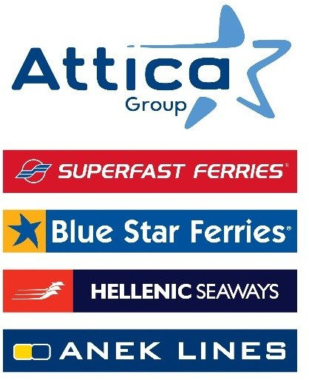

Athens, June 08, 2025

Attica Group: Release of the 16th Responsible and Sustainable Development Report

for the second consecutive year, ranked among the world’s leading companies according to Standard & Poor’s assessment

With a clear sense of responsibility for Attica Group, the leader in Greek passenger shipping sector and one of the largest passenger shipping companies worldwide, the principles of Responsible and Sustainable Development remain inextricably linked to the Group’s business strategy and activity, for the achievement of economic results and the creation value for the stakeholders. This strong commitment is reflected in all aspects of Attica Group’s operation with steady and strong performance across all ESG indicators as reflected in the 16th Responsibility and Sustainability Report 2024 recently published.

The Group’s high performance and the effectiveness of the planning and implementation of the Responsible and Sustainable Development strategy were confirmed for a second consecutive year, in 2024, within the framework of the assessment by Standard & Poor’s Global Corporate Sustainability Assessment (CSA), which ranks Attica Group within the top 23% of leading companies worldwide in the broader industry sector of Transportation and Transportation Infrastructure. At the same time, the assessment of S&P ESG Score improved by 19.4% compared to 2023, highlighting the Group’s commitment to continuous improvement and compliance with international sustainability standards.

As reflected in the 16th Responsible and Sustainable Development Report, in the field of “Environment”, enhancing fleet energy efficiency and minimizing environmental impact on land and at sea remain constant priorities. Faithful to the commitment to reducing carbon emissions per mile by 14% by 2030 compared to 2019, as set out in the Decarbonization Roadmap, planned and implemented since 2022, Attica Group remains consistent with meeting intermediate targets through the implementation of a multi-level strategy.

In 2024, it was the first company in Greece to include a comprehensive Climate Change Study in its 2024 Financial Statements. Based on the findings of this Study, a dedicated policy was developed, with the primary objective of actively contributing to the mitigation and/or elimination of the impacts of climate change. For the first time, short, medium and long-term scenarios were taken into account (with an increase in global average temperature of 1.5°C, 2°C and 3°C) in order to assess future risks and opportunities.

The footprint is also significant in the “Society” area, as the financial value distributed totally by the Group for employees, taxes, capital providers, agents, suppliers, society and investments amounted to € 974.5 million, an increase of 43.2% compared to 2023.

Showing respect to its passengers and the vital role it plays in ensuring connectivity, it more than doubled the number of discounted tickets offered to support social programs (indicatively Non-Governmental Organizations, sports/cultural associations, etc.) from 120,000 tickets in 2023 to 320,000 in 2024 (an increase of 163%), with the corresponding value of discounts rising from EUR 3.3 million in 2023, to € 7.7 million in 2024. Overall, the value of the social contribution amounted to €8m.

It is worth noting that in the context of the expanded commercial and social program of offers and discounts implemented by the Group in 2024, more than 3.6 million passengers benefited from discounts with a total value of more than €100 million.

Attica Group, being the biggest employer of Greek seafarers and employing more than 3,000 employees, sets as strategic priority the continuous development of the Group’s people. In 2024, through a targeted skills acquisition and upgrading program, more than 14,000 hours of training were completed.

At the same time, within the framework of the implementation of an extended Corporate Social Responsibility program, Attica Group implemented or supported initiatives and social programs across 100% of the islands in which it operates, contributing to the improvement of daily life for local island communities. The total number of beneficiaries more than tripled compared to 2023.

In the “Corporate Governance” pillar, Attica Group, committed to transparency and accountability, complies with applicable law and adopts international best practices and standards while having increased the number of relevant indicators it publishes by 91%, compared to 2018.

You can find the responsible and Sustainable Development Report here and the summary here.

Attica Group in brief

Attica Group is the leading passenger shipping operator in Greece, with a long-standing presence in the Greek and international seas, that ranks amongst the largest passenger shipping companies worldwide.

Operating under the well – established brands of Superfast Ferries, Blue Star Ferries, Hellenic Seaways and ANEK Lines, with a fleet of 43 vessels and more than 3,000 employees ashore and at sea, Attica Group connects daily, more than 55 destinations, offering high-quality transport services in Greece and international routes (Greece – Italy). In recent years, the Group expanded its presence in the tourism sector, by acquiring hotel units on the islands of Tinos (1) and Naxos (2) where it operates, aiming to provide holistic travelling experiences for its clients.

Growth oriented and consistent to its commitment to incorporate the principles of responsible and sustainable development across the entire range of its business activities and operations, Attica Group invests in practices that minimize its environmental impact while creating value for shareholders, employees and local communities.

Contact Details:
Kallia Mylonaki, Corporate Communications Director
Tel: +30 210 891 9150, email: mylonaki@attica-group.com

