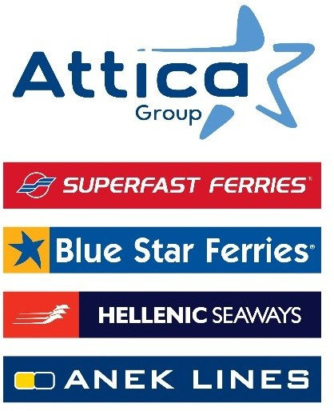

Athens, 10 July 2025

**10 awards for Attica Group at the Health & Safety Awards 2025**

***For the 3rd consecutive year***

***the Attica Group team is honoured as***

***“Occupational Health & Safety Team of the Year”***

Attica Group, received a total of 10 awards, including the honour of **“Occupational Health & Safety Team of the Year”** at the Health & Safety Awards 2025, confirming its unwavering and long-standing commitment to the Health & Safety of its employees at sea and ashore, as well as of its passengers onboard Group’s vessels.

This year awards reaffirm Attica Group’s dedication to prevention, implementing safety practices across all its operations, specifically:

**Occupational Health & Safety Team of the Year**

*Top award of the event*

**Winner** award in the category:

* *Transportation (Air, Rail, Sea, Public)*

**Gold** award in following categories:

* *Healthy & Safe Workplace*
* *Premises Evacuation*
* *Behavioral Risk Management*
* *Community Health Development*
* *Fire Fighting & Safety Equipment*

**Silver** award in following categories:

* *Accessibility for People with Disabilities*
* *Visitor Management*
* *Health & Safety System Update & Improvement*

For Attica Group, with over 3,000 employees, creating a work environment focused on people and their safety - through ongoing investment in infrastructure, know-how, training and a prevention-oriented culture - reflects its Vision and Values, while reinforcing its commitment to deliver high-quality services to passengers who choose to travel with its fleet.

*Attica Group in brief*

*Attica Group is the leading passenger shipping operator in Greece, with a long-standing presence in the Greek and international seas, that ranks amongst the largest passenger shipping companies worldwide.*

*Operating under the well – established brands of Superfast Ferries, Blue Star Ferries, Hellenic Seaways and ANEK Lines, with a fleet of 43 vessels and more than 3,000 employees ashore and at sea, Attica Group connects daily, more than 55 destinations, offering high-quality transport services in Greece and international routes (Greece – Italy). In recent years, the Group expanded its presence in the tourism sector, by acquiring hotel units on the islands of Tinos (1) and Naxos (2) where it operates, aiming to provide holistic travelling experiences for its clients.*

*Growth oriented and consistent to its commitment to incorporate the principles of responsible and sustainable development across the entire range of its business activities and operations, Attica Group invests in practices that minimize its environmental impact while creating value for shareholders, employees, and local communities.*

Contact details:

Kallia Mylonaki, Corporate Communications Director

tel.: +30 210 891 9150, email: [mylonaki@attica-group.com](mailto:mylonaki@attica-group.com)