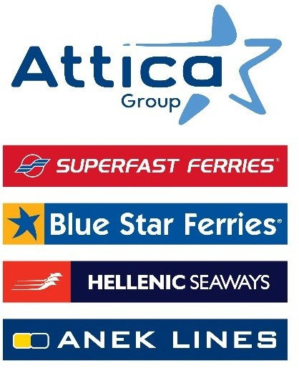

Athens, December 19, 2024

New State-of-the-Art WiFi Onboard Services

Strategic partnership between Attica Group
and the leading companies Orbyt Global & Telenor Maritime

Attica Group, responding to the needs of its passengers and crew, is entering into a strategic partnership with Orbyt Global & Telenor Maritime to upgrade telecommunications and connectivity services on board. The Group aims to continuously enhance the travel experience by providing modern, reliable services, including stable, high-speed Internet access and telecommunications throughout the stay on board, even in the most remote areas.

Working with Orbyt Global and Telenor Maritime, leading companies in providing high-tech telecommunication and satellite communication solutions for the shipping industry, will deliver high-speed connectivity through Low Earth Orbit (LEO) satellites by Starlink. Simultaneously, the implementation of an advanced interface platform will enable the integration of multiple satellite and terrestrial network technologies (LEO, GEO, 4G, and 5G) into a unified system. In this way, the automatic selection of the optimal connection in real-time will be achieved, enabling the passengers and crews of the Attica Group to enjoy advanced and reliable telecommunications and Wi-Fi services onboard.

The agreement includes a total investment of €7mn from Orbyt Global and Telenor Maritime for the development and provision of a comprehensive onboard connectivity technology solution. It has a five-year duration with an option for a five-year renewal. Based on the target setting, the project will be expanded to the Group’s entire fleet operating under the commercial brands Blue Star Ferries, Superfast Ferries, Hellenic Seaways and ANEK lines and is expected to be completed in 2025.

Mr. Panos Dikaios, Chief Executive Officer of Attica Group, commented: “We respond to the needs of our passengers and crew by investing in digital infrastructure bearing the signature of reliability from the leading companies Orbyt Global and Telenor Maritime. Our investment in new generation technologies accelerates the digital transformation process of our Group, with multiple benefits for our passengers, employees and operations.

Leveraging the best available technologies enables us to create personalized experiences for our passengers, offering greater comfort and convenience throughout their journey. Similarly, the benefits for our crews will be significant, as they will have the ability to communicate with their families even from the most remote areas and enjoy entertainment services during their free time. At the same time, uninterrupted connectivity services will further enhance the efficient use of data, enabling faster decision-making in real-time.”

Attica Group in brief

Attica Group is the leading passenger shipping operator in Greece, with a long-standing presence in the Greek and international seas, that ranks amongst the largest passenger shipping companies worldwide.

Operating under the well – established brands of Superfast Ferries, Blue Star Ferries, Hellenic Seaways and ANEK Lines, with a fleet of 43 vessels and more than 3,000 employees ashore and at sea, Attica Group connects daily, more than 55 destinations, offering high-quality transport services in Greece and international routes (Greece – Italy). In recent years, the Group expanded its presence in the tourism sector, by acquiring hotel units on the islands of Tinos (1) and Naxos (2) where it operates, aiming to provide holistic travelling experiences for its clients.

Growth oriented and consistent to its commitment to incorporate the principles of responsible and sustainable development across the entire range of its business activities and operations, Attica Group invests in practices that minimize its environmental impact while creating value for shareholders, employees and local communities.

Contact Details:
Kallia Mylonaki, Corporate Communications Director
Tel: +30 210 891 9150 (1571), email: mylonaki@attica-group.com

