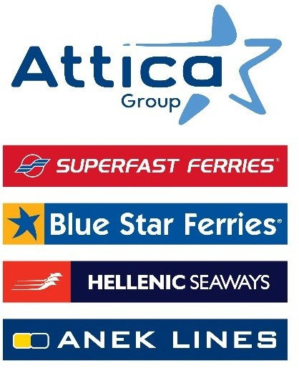

Athens, 16 May 2025

Attica Group honoured with 21 awards
at the Tourism & Travel Marketing Awards 2025
1 Platinum & Gold, 9 Gold, 7 Silver and 3 Bronze awards
for actions relating to
Responsible & Sustainable Development
and Innovative Customer Service Practices

The Group Marketing Team receives the “In-House Marketing Team of the Year” award for the 2nd consecutive year

Attica Group, through its companies Superfast Ferries, Blue Star Ferries, Hellenic Seaways and Anek Lines, won a total of 21 awards at the Tourism & Travel Marketing Awards 2025 ceremony, held on 12 May. Specifically, the Group received 1 Platinum & Gold, 9 Gold, 7 Silver and 3 Bronze awards for initiatives that advance sustainability and enhance the passenger travel experience.

Moreover, the Group's Marketing team was recognised as the “In-House Marketing Team of the Year” for the 2nd consecutive year, affirming its effective strategy and dynamic presence in the travel marketing segment.

The awards cover a wide range of initiatives, recognising:
- the effective implementation of the ESG strategy and commitment to responsible business.
- the marketing initiatives that elevate the passenger experience and enhance the Group’s communication across all points of interaction, both online and offline.
- Seasmiles, the largest loyalty program in Greek shipping sector, which transforms every journey into a rewarding experience offering extra value and privileges.
- the best practices for the health and safety of both passengers and employees.
- the Group’s targeted social actions and consistent support to the island communities where it operates.
- the actions aimed at enhancing equal access to tourism and promote inclusion.

These initiatives embody Attica Group’s vision and strategic direction, consistently embedding ESG principles into every aspect of its operations. Through targeted actions, the Group demonstrates its commitment to empowering local communities and enhancing the passenger experience, delivering meaningful benefits to both residents and visitors of the country’s island regions.

Attica Group in brief

Attica Group is the leading passenger shipping operator in Greece, with a long-standing presence in the Greek and international seas, that ranks amongst the largest passenger shipping companies worldwide.

Operating under the well – established brands of Superfast Ferries, Blue Star Ferries, Hellenic Seaways and ANEK Lines, with a fleet of 43 vessels and more than 3,000 employees ashore and at sea, Attica Group connects daily, more than 55 destinations, offering high-quality transport services in Greece and international routes (Greece – Italy). In recent years, the Group expanded its presence in the tourism sector, by acquiring hotel units on the islands of Tinos (1) and Naxos (2), where it operates, aiming to provide holistic travelling experiences for its clients.

Growth oriented and consistent to its commitment to incorporate the principles of responsible and sustainable development across the entire range of its business activities and operations, Attica Group invests in practices that minimize its environmental impact while creating value for shareholders, employees and local communities.

Contact details:
Kallia Mylonaki, Corporate Communications Director
tel.: +30 210 891 9150 (1571), email: mylonaki@attica-group.com

