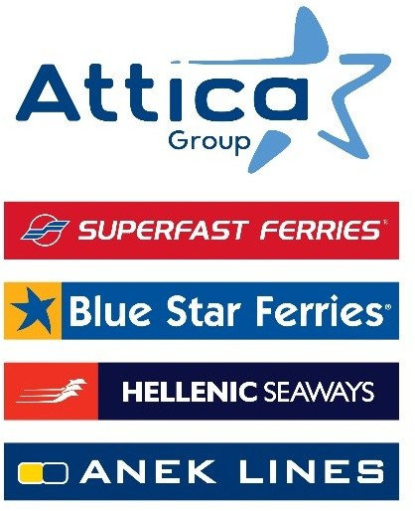

Athens, May 29, 2025

Attica Group’s 8th Environmental Initiative
in Rhodes and Chalki

With the participation of more than 650 students,
90 employees – volunteers of the Group, 2 Non-Governmental Organizations

Attica Group, with the participation of 90 employees – volunteers, visited the islands of Rhodes and Chalki, from 8 to 11 May 2025, carrying out the 8th – in a row – Environmental Initiative, an important environmental and educational action within the framework of the Responsible and Sustainable Development Program “Sailing Together”.

This action was implemented in collaboration with the Non-Governmental Organizations (NGOs), Aegean Rebreath and Planet Agents, aiming to enhance the environmental education and awareness of students and to contribute substantially to the protection of the marine ecosystem of both islands.

Environment & Education in Schools
On May 8 and 9, more than 650 students in 5 primary schools of Rhodes participated in interactive, environment-related educational activities, which were designed and implemented by the Planet Agents team. The aim of the program was to contribute to the cultivation of environmental awareness through the implementation of experiential educational programs that help students take an active role in the protection of the ecosystem of their islands.

Environment & underwater Cleanup
Demonstrating its continued commitment to marine environmental protection, Attica Group once again partnered with the leading environmental NGO, Aegean Rebreath, participating in a seabed cleanup initiative in Mandraki port of Rhodes as well as on the island of Chalki, on May 10 and 11.

More than 90 Group employees visited the two islands to actively support the protection of the marine environment by volunteering in the initiative. Within two days, the volunteers, under Aegean Rebreath guidance, collected more than 3,800 recyclable items, including plastics, vehicle tires, metals, aluminum, glass, ceramics, etc that were subsequently sorted by material, with their next destination being recycling.

The 8th Environmental Initiative matches knowledge with action, creating value for local communities and future generations.

Mr. Panagiotis Papadodimas, Chief Administrative & Transformation Officer and Head of tAttica Group’s Responsible and Sustainable Development team, stated: “Attica Group’s 8th Environmental Initiative in Rhodes and Chalki was yet another opportunity to stand by the islanders and support the needs of the local community. Through our collaboration with Aegean Rebreath and the Planet Agents and also through the active participation of our employees, we strengthen the islands, protect the marine environment and promote their sustainable development.”

From 2021 to this day, 8 actions in total have taken place in Naxos, Paros, Kos, Santorini, Lesvos, Poros and Chania, with the most recent being Rhodes and Chalki. Through ongoing partnerships with NGOs, active engagement in schools, and continuous support for its volunteers, Attica Group consistently reaffirms its commitment to a sustainable future, transforming environmental responsibility into a shared cause and collective action.

Attica Group in brief

Attica Group is the leading passenger shipping operator in Greece, with a long-standing presence in the Greek and international seas, that ranks amongst the largest passenger shipping companies worldwide.

Operating under the well – established brands of Superfast Ferries, Blue Star Ferries, Hellenic Seaways and ANEK Lines, with a fleet of 43 vessels and more than 3,000 employees ashore and at sea, Attica Group connects daily, more than 55 destinations, offering high-quality transport services in Greece and international routes (Greece – Italy). In recent years, the Group expanded its presence in the tourism sector, by acquiring hotel units on the islands of Tinos (1) and Naxos (2) where it operates, aiming to provide holistic travelling experiences for its clients.

Growth oriented and consistent to its commitment to incorporate the principles of responsible and sustainable development across the entire range of its business activities and operations, Attica Group invests in practices that minimize its environmental impact while creating value for shareholders, employees and local communities.

Contact Details:
Kallia Mylonaki, Corporate Communications Director
Tel: +30 210 891 9150, email: mylonaki@attica-group.com

