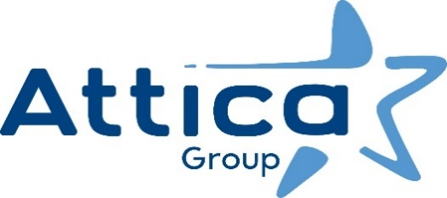

Athens, 13 November 2024

**International Certificate Award to Attica Group’s Internal Audit**

**by IFACI**

**Attica Group** received the highest distinction for the **Internal Audit, obtaining the international certificate from IFACI (French Institute of Audit and Internal Control)**.

**Attica Group is the first Greek Passenger Shipping Group** to **be certified for the Internal Audit activities** by the French organization IFACI, confirming that it fulfils the requirements of the Internal Audit Professional Framework (RPAI 2020) and complies with the International Professional Practices Framework (IPPF) of the international Institute of Internal Auditors.

The rigorous audit, carried out by IFACI, included **an evaluation of the Internal Audit in relation to each item of the International Standards of the Institute of Internal Auditors (IIA),** throughthematic workshops and a thorough review of the Unit’s documents and procedures, the departments involved as well as the Group's Management.

**By virtue of this certification, Attica Group joins a circle of large international IFACI-certified companies, confirming its commitment to the implementation of best practices and its firm dedication to the effective operation of the Group**. It is noted that only 6 IFACI certificates have been granted in Greece so far - including Attica Group.

IFACI is officially recognised by the international Institute of Internal Auditors (IIA) and the European Confederation of Institutes of Internal Auditors (ECIIA). **IFACI certification is proof of** **an independent, impartial assessment, confirming the proper and quality functioning of the Group's Internal Audit Unit.**

*Attica Group in brief*

*Attica Group is the leading passenger shipping operator in Greece, with a long-standing presence in the Greek and international seas, that ranks amongst the largest passenger shipping companies worldwide.*

*Operating under the well – established brands of Superfast Ferries, Blue Star Ferries, Hellenic Seaways and ANEK Lines, with a fleet of 43 vessels and more than 3,000 employees ashore and at sea, Attica Group connects daily, more than 55 destinations, offering high-quality transport services in Greece and international routes (Greece – Italy). In recent years, the Group expanded its presence in the tourism sector, by acquiring hotel units on the islands of Tinos (1) and Naxos (2) where it operates, aiming to provide holistic travelling experiences for its clients.*

*Growth oriented and consistent to its commitment to incorporate the principles of responsible and sustainable development across the entire range of its business activities and operations, Attica Group invests in practices that minimize its environmental impact while creating value for shareholders, employees and local communities.*

Contact details:

Kallia Mylonaki, Corporate Communications Director

tel.: +30 210 891 9150, email: [mylonaki@attica-group.com](mailto:mylonaki@attica-group.com)