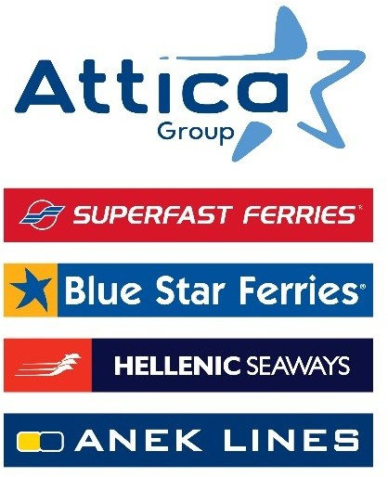

Athens, July 16, 2025

**Attica Group strengthens**

**its organizational structure with the new Customer Value Pillar**

***Spiros Doukas was appointed Chief Customer Value Officer of Attica Group***

Attica Group, in line with its ongoing development and customer-centric philosophy, is enhancing its structure through the establishment of a **new Customer Value Pillar**, aiming to continuously upgrade the customer experience and create value in each phase of interaction with the Group and the brands it represents – Superfast Ferries, Blue Star Ferries, Hellenic Seaways, Anek lines.

**Attica Group’s new Customer Value Pillar** includes the **Customer Experience Department**, the **Loyalty Division,** the **Marketing Department** and **the Hotel Operations Department.**

In this context, Attica Group **welcomes** **Mr. Spiros Doukas as Chief Customer Value Officer**. Mr. Doukas has 23 years of experience in the telecommunications and entertainment sectors, having led the design and implementation of a range of Loyalty Programs, the creation of personalized experiences, the development of a holistic Customer Experience Management system, and the launch of innovative services leveraging digital channels and new technologies, within leading companies. He is a graduate of the Department of Electrical & Computer Engineering of the University of Patras and holds an MBA from Athens University of Economics and Business.

The ongoing upgrading of services and the optimal servicing of our passengers have long been a strategic priority of Attica Group. To this end, it is investing—among other initiatives—in modern infrastructure and technology to shape an evolving and personalized experience that meets the contemporary needs and diverse profiles of passengers.

Since 2023, through the implementation of an expanded digital transformation project using new technologies and AI, the Group has initiated the integration of its digital systems to gain deeper insights into passenger needs, enhance customer rewards, and deliver unified, seamless, and reliable experiences. The personalized experience of each passenger is further enriched through the development of innovative digital interaction points designed to provide more direct and effective service-such as the new mobile application, conceived as a "travel companion, **Seamore**. At the same time, Attica Group has **Seasmiles**, the largest loyalty program for Greek ferry companies to provide benefits and discounts of up to 40% for its 800,000 members.

*Attica Group in brief*

*Attica Group is the leading passenger shipping operator in Greece, with a long-standing presence in the Greek and international seas, that ranks amongst the largest passenger shipping companies worldwide.*

*Operating under the well – established brands of Superfast Ferries, Blue Star Ferries, Hellenic Seaways and ANEK Lines, with a fleet of 43 vessels and more than 3,000 employees ashore and at sea, Attica Group connects daily, more than 55 destinations, offering high-quality transport services in Greece and international routes (Greece – Italy). In recent years, the Group expanded its presence in the tourism sector, by acquiring hotel units on the islands of Tinos (1) and Naxos (2) where it operates, aiming to provide holistic travelling experiences for its clients.*

*Growth oriented and consistent to its commitment to incorporate the principles of responsible and sustainable development across the entire range of its business activities and operations, Attica Group invests in practices that minimize its environmental impact while creating value for shareholders, employees and local communities.*

Contact Details:

Kallia Mylonaki, Corporate Communications Director

Tel: +30 210 891 9150, email: [mylonaki@attica-group.com](mailto:mylonaki@attica-group.com)